**Batch Scoring Architecture Example**

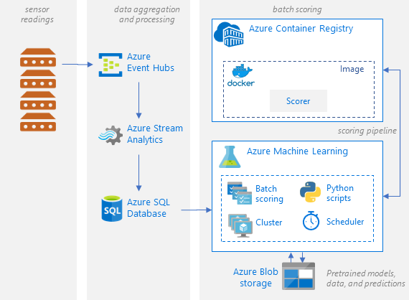

* **Can also create endpoint to send scored results to Web App or Dashboard service (Power BI)**

<https://docs.microsoft.com/en-us/azure/architecture/reference-architectures/ai/batch-scoring-python>